|  |  |  |  |  |  |  |  |  |
| --- | --- | --- | --- | --- | --- | --- | --- | --- |
| **appNo** | **date/time** | **instructorID** | **iFName** | **iLName** | **clientIDD** | **cFName** | **cLName** | **cAddress** |
| 1001 | 2016-10-12 09:00 | I456 | Jane | Watt | C034 | Anne | Way | 111 Storrie Road, Paisley |
| 1102 | 2016-10-12 10:00 | I456 | Jane | Watt | C034 | Anne | Way | 111 Storrie Road, Paisley |
| 1203 | 2016-10-12 09:00 | I344 | Tom | Jones | C034 | Anne | Way | 111 Storrie Road, Paisley |
| 1334 | 2016-11-12 13:00 | I666 | Karen | Black | C089 | Mark | Fields | 120 Lady Lane, Paisley |
| 1455 | 2016-11-12 14:00 | I957 | Steven | Smith | C019 | John | Brown | 13 Renfrew Road, Paisley |
| 1676 | 2016-11-12 14:00 | I344 | Tom | Jones | C039 | Karen | Worth | 34 High Street, Paisley |

COMP 3610 Review Exercises

Normalization (Chapter , ERD, EERD, logical modelling (Chapter 17)

The following table represents data for the appointments in a driving school We-teach-U-how-2-drive. All appointment are for 1 hour.

1. The data in the table is susceptible to update anomalies. Provide examples of how insertion, deletion, and modification anomalies could occur on this table.
2. Identify the functional dependencies represented by the data shown in the table. State any assumptions you make about the data.
3. Draw a conceptual model for the database to represent the above data.
4. Map the conceptual model (ERD) into a logical model (relational). List the relations with primary and foreign keys.
5. Normalize (up to 3NF) the relations if required (most likely the relations will be in 3NF).

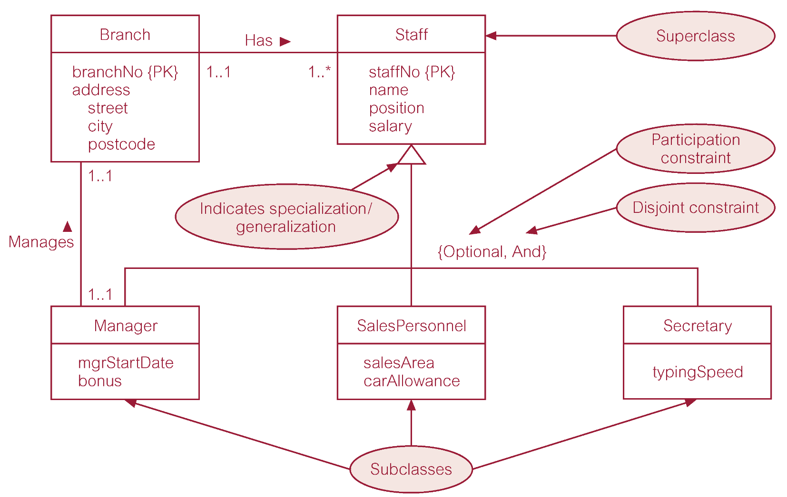

Use the above EERD. Map the EERD to a logical model (relational model). Use table 17.1 from **chapter 17.**

